Drahokamy
- Jaspis (Jasper)
- Safír 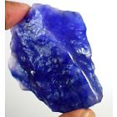
- Chalcedon 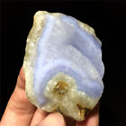
- Smaragd (Emerald)
- Sardonyx
- Karneol (Carnelian)
- Chrysolit
- Beryl 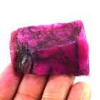
- Topas 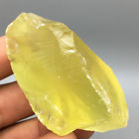
- Chrysopras 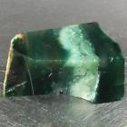 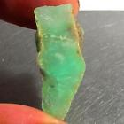
- Hyacint
- Ametyst (Amethyst) 


